** Question/Answer Booklet**

**Name: MEMO**

**PHYSICAL EDUCATION STUDIES YEAR 11 ATAR**

**Semester 1 Exam 2021**

**Time allowed for this paper**

Reading time before commencing work: 0 minutes

Working time for paper: 2 Hours

***To be provided by the candidate***

Standard items: pens (blue and black), pencils, eraser, correction fluid, ruler, highlighter

**Important note to candidates**

No other items may be taken into the examination room. It is **your** responsibility to ensure that you do not have any unauthorised notes or other items of a non-personal nature in the examination room. If you have any unauthorised material with you, hand it to the supervisor **before** reading any further.

**Structure of paper:**

|  |  |  |  |
| --- | --- | --- | --- |
| Section | Number of questions available | Number of questions to be attempted | Marks available |
| **Section One:**  Multiple-Choice | 20 | 20 | 20 |
| **Section Two:**  Short Answer | 17 | 17 | 70 |
| **Section Three:**  Extended Answer | 3 | 2 | 20 |
|  |  |  | **110** |

Answer the twenty **(20)** Multiple-Choice questions on the separate Multiple-Choice answer sheet provided.

**Multiple Choice (20 marks)**

1. Which one of the following statements is **true** of the bloods pathway?
2. Blood enters the Right Ventricle, then flows to the Right Atrium, before traveling into the Pulmonary Vein and returns to the heart via the Pulmonary Artery.
3. Blood enters the Left Atrium, then flows to the Left Ventricle, before traveling into the Pulmonary Artery and returns to the heart via the Pulmonary Vein.
4. Blood enters the Right Atrium, then flows to the Right Ventricle, before traveling into the Pulmonary Artery and returns to the heart via the Pulmonary Vein.

(d) Blood enters the Right Atrium, then flows to the Right Ventricle, before traveling into the Pulmonary Vein and returns to the heart via the Pulmonary Artery.

1. An Anterior Cruciate Ligament (ACL) knee injury is one of the most devastating injuries that an elite AFL footballer can sustain. The ACL connects which two structures?

(a) Tibia to the Hamstring Muscle.

(b) Tibia to the Femur.

(c) Tibia to the Meniscus Cartilage.

(d) Tibia to the Hamstring Tendon.

1. Controlled breathing techniques are often used by athletes as a relaxation technique. When an athlete breathes out:

(a) the diaphragm relaxes and the intercostal muscles relax.

(b) the diaphragm relaxes and the intercostal muscles contract.

(c) the diaphragm contracts and the intercostal muscles contract.

(d) the volume of the lungs increases.

4. Where is the heart located in relation to the sternum?

1. Superior
2. Inferior
3. Anterior
4. Posterior
5. In water polo, goal keepers defend by elevating their arms above their head. Which superficial muscle of the back contracts to elevate the scapula and produce the defensive position shown in the image below?



(a) Trapezius

(b) Triceps

(c) Deltoid

(d) Latissimus Dorsi

6. In the action of spiking a volleyball, the velocity of the ball will depend on the total force applied. The force applied will depend upon:

(a) the power of the smallest muscle groups.

(b) the power of the largest muscle groups.

(c) the velocity of the last body part.

(d) the velocity of the first body part.

1. The type of motion that a sprinter exhibits in running a 100m sprint would best be

described as:

(a) general motion.

(b) linear motion.

(c) angular motion.

(d) projectile motion.

1. Which of the following is **not** an example of Newton’s first law of motion in cricket?
   1. the bat contacting the ball.
   2. the ball hitting the boundary fence and changing direction.
   3. the ball stopping immediately when caught by a player.
   4. the speed of the cricket bat directly prior to impact with the ball.
2. In the sport of lacrosse, players are required to be agile and well balanced. A player is demonstrating dynamic balance when:

(a) they are moving towards their centre of gravity.

(b) their centre of gravity is within the body.

(c) their line of gravity is within their base of support.

(d) they are stationary.

1. Submaximal force is required during some sporting situations to produce optimal performance. Which of the following is the best example of submaximal force application?

(a) pushing of the blocks in a swimming dive start.

(b) hitting a drop shot in badminton.

(c) griping a tennis racket in preparation for an overhead smash shot.

(d) execution of a well-timed high jump.

1. Performing a triple jump can be classified as a:

(a) Discrete motor skill.

(b) Continuous motor skill.

(c) Serial motor skill.

(d) Motor skill.

1. At half-time in an Inter-School touch rugby game, a coach speaks to her players about the need to be more accountable in defending their try line, by maintaining communication and evenly positioning themselves across the field. This is an example of:

(a) intrinsic feedback.

(b) concurrent feedback.

(c) constructive feedback.

(d) terminal feedback.

13. A surfer is warming up on the beach practising the movement of ‘popping-up’ onto the board. Which type of cues is she relying on to improve her body position?

(a) visual

(b) proprioceptive

(c) verbal

(d) balance

1. The beam is renowned as the ultimate test of nerves for female gymnasts, unforgiving in exposing any lack of focus or preparation. The national coach of a gymnast knows that her athlete performs best when she focuses on her technique and not the score required to make the final in this apparatus. Based on this information, which of the following types of feedback should the coach provide?

(a) knowledge of performance.

(b) intrinsic feedback.

(c) knowledge of result.

(d) terminal feedback.

15. A kayaker is paddling down a series of rapids on the Avon River and notices reduced water flow in one section due to a submerged tree log. The kayaker realises it will be too difficult for the kayak’s hull to clear this section, so does not attempt to navigate the hazard. According to the information-processing model, what stage of the model did the kayaker reach?

(a) identification of stimuli/input.

(b) response identification/decision-making.

(c) response/output.

(d) feedback

16. Feedback about the outcome of a performance such as seeing your time for a 100-metre running sprint is known as:

(a) knowledge of outcome.

(b) knowledge of performance.

(c) knowledge of results.

(d) knowledge of success.

17. In which of the following examples is Newton’s third law most evident?

(a) Rowing a boat.

(b) Performing a handstand.

(c) Applying spin to a soccer ball.

(d) Giving with the ball when catching a cricket ball.

18. The mechanism responsible for increased blood flow to the working muscles is:

(a) vasoconstriction

(b) vasodilation

(c) the muscle pump.

(d) reduced cardiac output.

19. When a learner decides on or develops a motor program based on information input, they are likely to be in which stage of the information processing model?

(a) Identification of stimuli/input.

(b) Response identification/decision making.

(c) Response/output.

(d) Feedback

20. A softball player has two bats, one of which is 300 grams heavier than the other. If the player swings both bats at the same velocity, the heavier bat will be able to produce greater ________ than the lighter bat.

(a) acceleration

(b) momentum

(c) force

(d) torque

**Short Answer (70 marks)**

This section has **Seventeen (17** **questions**). Answer **all** questions. Write your answers in the spaces provided in this Question/Answer Booklet. Wherever possible, confine your answers to the line spaces provided. Use a blue or black pen (**not** pencil) for this section.

**Question 21 (6 marks)**

The following question relates to the image below of the footballer performing a defensive slide tackle.

.

1. Identify the articulating bones of the hip joint. (2 marks)

|  |  |
| --- | --- |
| **Correctly identifies** | **2 Marks** |
| Femur | 1 mark |
| Pelvis | 1 mark |

1. Identify the movement of the defending players’ left knee and ankle which is attempting to intercept the ball in the tackle. (2 marks)

|  |  |
| --- | --- |
| **Correctly identifies** | **2 Marks** |
| Knee - Extension | 1 mark |
| Ankle – Dorsiflexion | 1 mark |

1. Identify the agonist muscles responsible for the movement in the defending players’ left knee and ankle. (2 marks)

|  |  |
| --- | --- |
| **Correctly identifies** | **2 Marks** |
| Knee - Quadriceps | 1 mark |
| Ankle – Tibialis Anterior | 1 mark |

**Question 22 (5 marks)**

* + 1. The personal trainer, pictured above, is advising his client about the importance of controlling the contraction of the Dumbbell curl. Explain how the muscles of the upper arm form a partnership that allows coordinated movement.

|  |  |
| --- | --- |
| **Description** | **Max 2 Marks** |
| States that biceps and triceps work as an agonist and antagonist pair to produce movement (flexion/ extension) at the elbow joint | 1 mark |
| Explains triceps contract to extend elbow whilst the biceps relax, biceps contract to flex elbow whilst triceps relax | 1 mark |
| As one muscle contracts (Bicep) the opposite muscle (triceps) progressively relaxes or relaxes in a controlled manner | 1 mark |

(2 marks

1. Briefly outline the function of the arteries, veins and capillaries in the circulatory system.

(3 marks)

|  |  |
| --- | --- |
| **Description** | **3 Marks** |
| Arteries – Transports blood away from the heart | 1 mark |
| Veins – Transports blood towards the heart | 1 mark |
| Capillaries – Where gaseous (O2 and CO2)exchange occurs / diffusion | 1 mark |

**Question 23 (5 marks)**

The wearing of face masks to prevent the transfer of COVID-19 has been mandatory amongst spectators and officials around sporting fixtures around the world. The World Health Organisation (WHO) does not recommend wearing a facial mask during exercise because it can make breathing more difficult and potentially a feeling of “light-headedness” when exercising during exertion. Explain the mechanics of breathing during inhalation and how wearing a facial mask during exercise could affect the concentration of gases entering the alveoli of the lungs.

|  |  |
| --- | --- |
| Description | **Max 5 Marks** |
| Contraction of diaphragm causes muscle sheet to flatten and increase volume of chest. | 1 mark |
| The intercostal muscles contract drawing the rib cage up and outwards which increases the volume in the chest. | 1 mark |
| The increased chest volume reduces air pressure inside the lungs. Pressure differential created (low pressure) relative to outside (high pressure) allows for the outside air to flow into the lungs. | 1 mark |
| Wearing masks increases the concentration of CO2 being inhaled, due to exhaled air being ‘trapped’ in the facial mask or reduced O2 concentration inhaled due to face mask preventing ‘fresh air flow’ to allow normal O2 levels from the open environment during respiration. | 1 mark |
| Gases (O2 and CO2)move from area of high pressure to area of low pressure within the alveoli. The low concentration gradient of O2 and CO2 will see a slower rate of diffusion of gases across the alveoli membrane. | 1 mark |

**Question 24 (5 marks)**

Identify the anatomical features within the right lung in the diagram below.

|  |
| --- |
| 1. Pulmonary Artery |
| 1. Trachea |
| 1. Pulmonary Vein |
| 1. Bronchi |
| E. Alveoli |

**Question 25 (3 marks)**

When trying to throw a javelin for distance, athletes need to coordinate the linear motion of the throwing arm to create linear velocity.

(a) Describe the **two (2)** factors the athlete can increase to maximise the amount of linear velocity transferred to the javelin. (2 marks)

|  |  |
| --- | --- |
| **Description** | **2 Marks** |
| Increase the angular velocity of the arm that is holding the javelin | 1 mark |
| Increase the length of the throwing arm | 1 mark |

(b) Give one example of how an athlete can modify their technique to maximise linear velocity.

(1 mark)

|  |  |
| --- | --- |
| **Description** | **1 Mark** |
| Include a run up / Increase their approach speed before throwing | 1 mark |

**Question 26 (2 marks)**

Sporting commentators often use the words “speed” and “acceleration” to describe an object or athlete’s movement in competition. Describe the difference between speed and acceleration?

|  |  |
| --- | --- |
| **Description** | **Max 2 Marks** |
| Speed is a measure of how fast an object / athlete moves relative to a reference point. How quickly an object is covering a given distance. Distance / Time | 1 mark |
| Acceleration is a measure of how quickly an object is changing its velocity over time. Measured in m/s/s or ms-2 | 1 mark |

**Question 27 (3 marks)**

Athletes receive multiple cues from their coaches in the efforts to improve performance. Identify **three (3)** different types of cues used by coaches, **providing an example** of how each cue could be used to assist in learning a new skill?

|  |  |
| --- | --- |
| **Description** | **6 Marks** |
| Identifies - **Verbal Cues** | 1 mark |
| Provides relevant example eg. coach states a few main teaching points, so the athlete is not overloaded with information | 1 mark |
| Identifies - **Visual Cues** | 1 mark |
| Provides relevant example eg. coach demonstrates how to perform a lay-up in basketball to a group of players | 1 mark |
| Identifies - **Proprioceptive Cues** | 1 mark |
| Provides relevant example eg. coach moves a badminton player’s arm and adjusts their grip on the racket in drop shot demonstration, so the player can feel the correct racket movement. | 1 mark |

**Question 28 (6 marks)**

Skiing is a popular recreational activity as well as a competitive sport. Classify skiing according to the following criteria. Clearly indicate on the continuum and justify your response for each.

(a) Muscle involvement (2 marks)

Fine Gross

|  |  |
| --- | --- |
| **Description** | **2 Marks** |
| Identifies skiing as being more gross than fine  Justification:  Skiing involves the use of the whole body, including the larger muscles of the legs, trunk and upper body to control body position | 1 mark  1 mark |

* 1. Environment (2 marks)

Closed Open

|  |  |
| --- | --- |
| **Description** | **2 Marks** |
| Identifies skiing at the higher end of an open environment  Justification:  Skiing is a highly varied environment due to mountain, altitude, snow and weather conditions which must be considered, each slope/run/bump is different. | 1 mark  1 mark |

(c) Continuity (2 marks)

Discrete Serial Continuous

|  |  |
| --- | --- |
| **Description** | **2 Marks** |
| Identifies skiing as being continuous  Justification:  Skiing does not have an easily identifiable / no definite start or finish (no clear beginning and end). | 1 mark  1 mark |

**Question 29 (3 marks)**

Passing is a fundamental skill of netball. A successful shoulder pass often requires a player to throw the netball with high velocity. Explain how the use of sequential movement can achieve maximal speed in a successful shoulder pass.

|  |  |
| --- | --- |
| Description | **Max 3 Marks** |
| Description of sequential movement (Any three of the following): |  |
| Largest body parts move first in the action, followed by the progressively smaller body parts in the shoulder pass eg. momentum starts with the legs and hips, trunk, shoulder, elbow, wrist, fingers | 1 mark |
| Maximal velocity is achieved in the shoulder pass when each body segment begins movement at the point when the previous body segment has reached maximal/peak velocity, or optimal momentum is achieved through efficient timing of each segment | 1 mark |
| The body needs to be well balanced/sequentially stabilising each segment to aid the transfer of momentum across each body segment. | 1 mark |
| Follow through in the shoulder pass allows acceleration of to be maintained through full range of movement and prevents deceleration until after release of netball | 1 mark |
| All muscular forces are directed to the target to maximise the summation of force and the accuracy of the shoulder pass to the intended receiver. | 1 mark |

**Question 30 (3 marks)**

Golf players use a variety of different clubs to ensure the golf ball travels the required distance. The angle on the club face affects the flight path and trajectory of the golf ball in the air. On the graph below, draw and label the three main trajectories a golf ball could make in its flight path in the air.

High

**Height**

Parabolic

Flat

**Distance**

|  |  |
| --- | --- |
| Description | 3 Marks |
| High trajectory  Parabola trajectory  Flat trajectory | Drawn and labelled correctly the three typical trajectories of a projectile.  (1 mark each) |

**Question 31 (2 marks)**

To achieve maximum horizontal distance, a projectile should be released at a 45⁰ angle. Other than shot put, explain one sporting example where it is necessary to have an angle greater than 45⁰, and one example where it is necessary to have an angle less than 45⁰.

|  |  |
| --- | --- |
| Marks | Possible answer |
| 1 mark  1 mark | **Greater than 45⁰**   * Appropriate example where landing height is higher than release point e.g. basketball free throw   **Less than 45⁰**   * Appropriate example where landing height is lower than release point e.g. hammer throw |

**Question 32 (6 marks)**

Using specific examples, identify **three (3)** types of motion in the picture below.

|  |  |
| --- | --- |
| Marks | Possible answer |
| 1 mark definition  1 mark example | * **Linear motion: This occurs when the whole body moves the same distance at the same time in the same direction.**   Any suitable example of movement in a straight line e.g. the boat |
| 1 mark definition  1 mark example | * **Angular motion: This motion occurs when the body moves around an axis of rotation.** * **All body parts involved travel through the same angle.**   Any suitable example of movement around an axis e.g. shoulders |
| 1 mark definition  1 mark example | **General motion: Combination of both**  Any suitable example of movement combing both linear and angular motion e.g. the rower’s body |

**Question 33 (3 marks)**

Define the terms positive, negative and zero acceleration and provide an example of each during a 200-metre freestyle swim.

|  |  |
| --- | --- |
| **Marks** | **Elaboration** |
| 1 mark – must have both defn and example | *Positive Acceleration*  Definition – the moving body is increasing in velocity (or similar)  Example – Leaving the blocks, first 2-5 strokes before reaching top speed |
| 1 mark – must have both defn and example | *Negative Acceleration*  Definition – the moving body is decreasing in velocity (or similar)  Example – Touching the wall before tumble-turn or end of race or final stages of race when fatigued |
| 1 mark – must have both defn and example | *Zero Acceleration*  Definition – the moving body is maintaining a constant velocity (or similar)  Example – Approx10 metre mark to the 45-metre mark of each lap (once top speed has been reached and before slowing for tumble-turn) |

**Question 34 (4 marks)**

Using examples, explain **two (2)** types of balance a gymnast may display during a floor routine.

|  |  |
| --- | --- |
| Marks | Possible answer |
| 1 mark  1 mark | **Static balance**  Ability to maintain equilibrium while stationary  Example – Handstand or suitable example |
| 1 mark  1 mark | **Dynamic balance**  Ability to maintain equilibrium while moving  Example – performing a series of somersaults or suitable example |

**Question 35 (4 marks)**

Cyclists in the Tour de France cycling race compete in teams and have support vehicles which provide nutrition, technical equipment and coaching support. Information on the race is also communicated via in-ear radio which provides feedback aiding in the potential success of the cycling team. Explain **two (2)** purposes of providing feedback to cyclists in such a race as the Tour de France.

|  |  |
| --- | --- |
| Description (Any two of the following) | Max 4 marks |
| **Feedback for reinforcement**  Reinforce what has been achieved so that cyclist can repeat what is required in team tactics / race finish  **Feedback for motivation**  Providing positive feedback to support, encourage, recognise cyclist and/or their efforts  **Feedback to modify performance**  Providing constructive feedback about positive aspects and areas to improve within the race. (eg. Upcoming mountain / sprint stage section) | 1 mark for purpose  1 mark for explanation  1 mark for purpose  1 mark for explanation  1 mark for purpose  1 mark for explanation |

**Question 36 (4 marks)**

Identify the **bones** on the diagram below. Answer in the space provided.

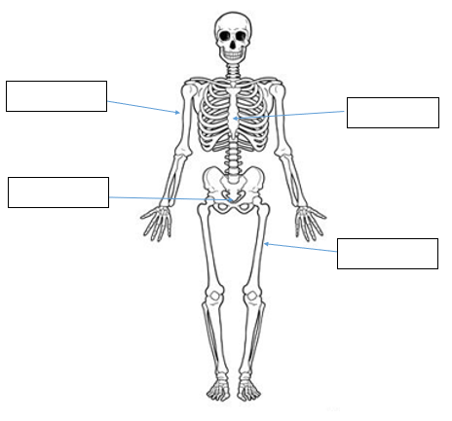

Femur

Sternum

Humerus

coccyx

**Question 37 (4 marks)**

Western Australia’s Jackson Symonds of Sorrento SLSC claimed a record fifth Open Beach Sprint title at the 2019 National Surf Lifesaving Championships. Successfully winning sprint running races requires a fast start. Using your understanding of the information-processing model, explain how Jackson would successfully get a way to an explosive start in the sprint.

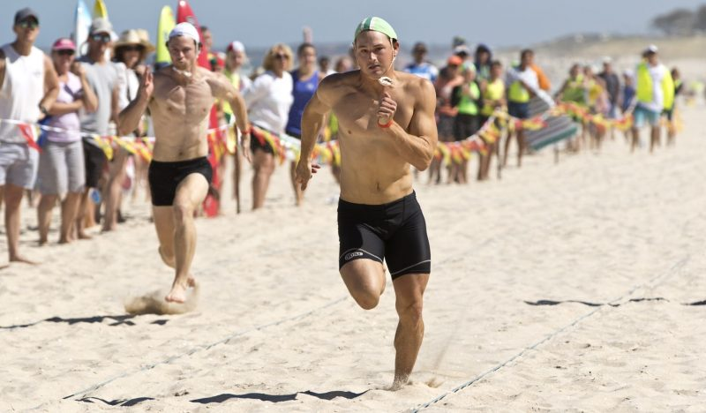

|  |  |
| --- | --- |
| **Description** | **Max 8 Marks** |
| **Stimuli/input stage**  Information is gathered from internal and external sources.  Stimulus detection of cues within the sporting environment. | 1 mark **explaining** stage |
| Jackson gathers information from external cues via hearing the starters gun (ears detect sound) | 1 mark description linking to the start of the race |
| **Response identification/ Decision making / Processing stage**  Information is processed / interpreted / analysed, and a response is selected.  Recognition of stimulus or response identification after processing the information or deciding how to respond to stimuli. | 1 mark **explaining** stage |
| Jackson’s brain recognises the starting gun and decides to trigger nerve impulse to activate muscle contractions to start movement after processing information. | 1 mark description linking to the start of the race |
| **Response / Output stage**  The muscular system carries out the movement or prepare and organise the muscular system to produce the required movement.  Selected movement is produced. | 1 mark **explaining** stage |
| Jackson’s legs muscles are activated to contract forcefully / start fast movement of running action to begin race | 1 mark description linking to the start of the race |
| **Feedback stage**  Information about the performance is received from the selected response.  Comparison of the performance against the desired performance. | 1 mark **explaining** stage |
| Jackson notices his reaction time was fast and he begins the race in a strong position out of the start line or provided with peripheral visual information as to the success of the start in relation to fellow competitors. | 1 mark description linking to the start of the race |

**Extended Answer (20 marks)**

**Question 38 (10 marks)**

Australian Cameron Smith came second at the 2020 US Masters and became the first player in the tournament’s history to shoot four consecutive rounds in the sixties. Smith ended up 15 under par having shot scores 67, 68, 69 and 69. His consistency came from good technique and the successful use of several biomechanical principles in putting, approach shots and driving the ball off the tee. Discuss the application of various golf shots in relation to the following biomechanical principles:

* Optimal Projection
* Segmental Interaction
* Balance

|  |  |
| --- | --- |
| Description – Optimal Projection | **Max 4 Marks** |
| Description of Optimal Projection - the relationship between angle, velocity and height of release to attain the goal. eg. distance | 1 mark |
| Velocity of release of a golf shot determines the height and length of the trajectory, providing all other factors are constant. | 1 mark |
| Increased velocity at the time of impact increases length of time in the air and distance travelled by the golf ball. A higher velocity of release/impact (eg. faster swing/transfer of angular velocity) will increase horizontal displacement and the achieved distance of the golf ball. | 1 mark |
| Angle of Projection/Release affects the projectile trajectory. The optimum angle of release, for a projectile being released at ground level, is 45 º | 1 mark |
| Optimal angle should slightly lower or higher (than 45º) depending on the approach shots location in comparison to the as the landing height of the target (green) | 1 mark |
| Height of Release influences the flight path of a projectile such as a golf ball or the height at which the golf ball is hit from affects the optimum angle of release. | 1 mark |
| The greater the height of release, the lower the angle of release/impact should be to increase the distance achieved. The height of release can mainly be determined by the natural geography of the course. If the ball is hit from a higher tee position in comparison to the landing height the greater the horizontal achieved. | 1 mark |
| Description – Segmental Interaction | **Max 4 Marks** |
| Description of sequential movement - how body segments/parts interact to meet the demands of the task or the forces acting between the segments of a body transfer energy between segments/parts | 1 mark |
| Largest body parts move first in the action, followed by the progressively smaller body parts in the golf shot eg. momentum starts with the trunk and hips, shoulder, elbow and wrist. | 1 mark |
| Maximal velocity is achieved in the golf shot when each body segment begins movement at the point when the previous body segment has reached maximal/peak velocity, | 1 mark |
| Optimal momentum is achieved through efficient timing of each segment / kinematic chain / sequential movement | 1 mark |
| Correctly labelled graph showing optimal timing transferring each segment - to assist explanation answer | 1 mark |
| The body needs to be well balanced/sequentially stabilising each segment to aid the transfer of momentum across each body segment. | 1 mark |
| Follow through in the golf shot allows acceleration of to be maintained through full range of movement and prevents deceleration until after the contact with the golf ball | 1 mark |
| All muscular forces are directed to the target to maximise the summation of force and the accuracy of the golf shot. | 1 mark |
| Description - Balance | **Max 4 Marks** |
| Description of Balance - is the ability to control your body's position and maintain a state of equilibrium, whether stationary or while moving | 1 mark |
| The closer the line of gravity is to the middle of the base of support the greater the stability of the golfer. Maintaining line of gravity within the base of support will create greater stability for each shot | 1 mark |
| A wider the base of support in the stance will provide greater stability which the golfer will have in maintaining control and balance, especially in shots which require accuracy such as putting. | 1 mark |
| By lowering the centre of gravity of the golfer’s body position, in bending his knees the greater the stability and control will be achieved. | 1 mark |

**Question 39 (10 marks)**

1. Using the three (3) athletes pictured below, discuss how the muscle fibre types

would vary for each athlete. In your answer, state each muscle fibre, include the

muscle fibre ratio of each.

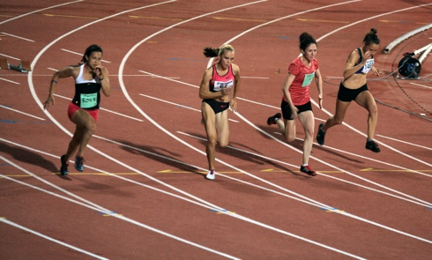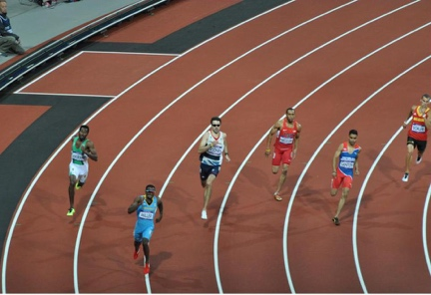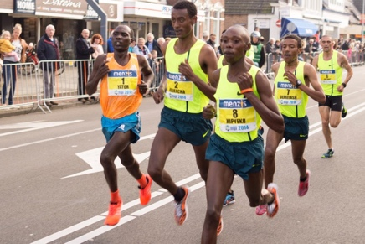

400m sprinter

Marathon runner

100m sprinter

(3 marks)

|  |  |
| --- | --- |
| Description | Marks |
| 100m sprinter would have a very high percentage of Type IIB fibres | 1 |
| 400m sprinter would have a very high percentage of Type IIA fibres | 1 |
| Marathon runner would have a very high percentage of Type I fibres | 1 |
|  |  |
| Characteristics of each fibre type (max 2 per fibre type = 2 marks). The characteristic **must** relate to improving the athletes performance in the given event |  |
| Type II B fibres  Any 2 of the following   * Rapid contraction speed * Very High force production * Very large in diameter * Very large motor neuron * Very high glycolytic capacity | 2*1 |
| Ratios of fibres  80:20  60:40  20:80 | 2*1 |
| Type I fibres  Any 2 of the following   * High capillary density * High oxidative density * High mitochondrial density * Slow contraction speed * Low force production * Fatigue resistant | 2*1 |

(b) Discuss how each of Newton’s three (3) Laws relate to the 100m sprint.

(7 marks)

|  |  |
| --- | --- |
| Description  1 mark for definition  1 mark for application to running sprint  1mark for naming all newtons laws | Marks |
| Newtons 1st law - A body continues in its state of rest or state of motion unless acted upon by a force  Application of Newtons 1st law – runner remains on starting block until force is created through contraction of muscles  Other relevant examples accepted | 1-2 |
| Newtons 2nd law - The acceleration of a body is proportional to the force applied to it, and inversely proportional to the mass of the object  Application of Newtons 2nd law – increase application of force in opposite direction results in greater acceleration  Other relevant examples accepted | 1-2 |
| Newtons 3rd law - For every action, there is an equal and opposite reaction  Application of Newtons 3rd law – pushing off the starting blocks, an equal and opposite force is applied sending the runner forward  or  runner applies a downwards and backwards force against the ground and the ground applies an equal and opposite force against the runner propelling them upwards and forwards  Other relevant examples accepted | 1-2 |

**Question 40 (10 marks)**

The three golfers pictured below are in different phases of their golf career. The child pictured on the left is attempting to hit a golf ball for the first time, the recreational golfer pictured in the middle is working to improve his game, while the adult pictured to the right is playing in a professional tournament.

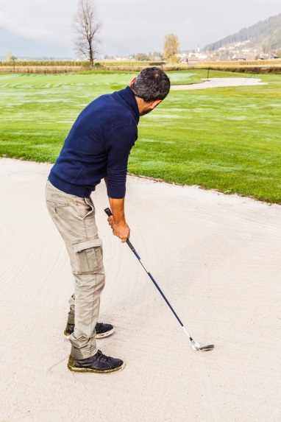

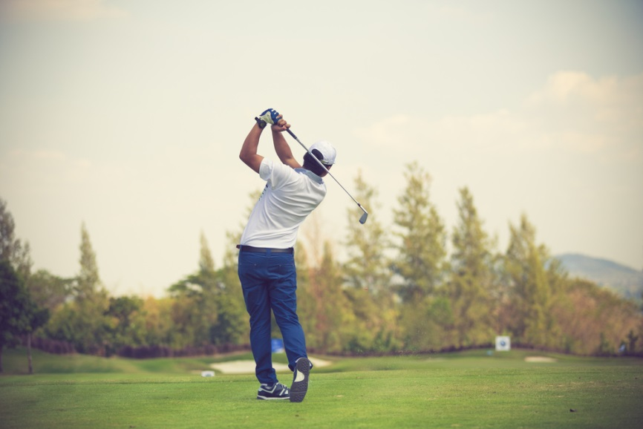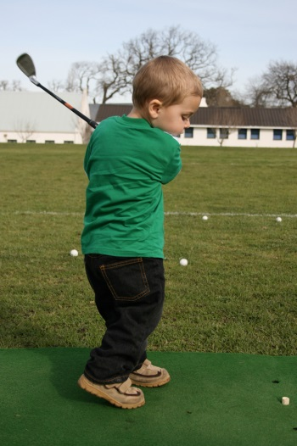

According to the Fitts and Posner model of skill learning, explain the three phases a golfer would move through as they progress from beginner level through to professional. In your response, identify the performance characteristics and type of feedback the learner would require in each phase to maximise their skill learning. Also identify the phase you would expect the golfer to spend the shortest amount of time in.

|  |  |
| --- | --- |
| **Marks** | **Elaboration** |
| 1 mark | Identifies ‘cognitive phase’ as the phase expected to spend the shortest amount of time in |
| 3 marks max  1 mark  1 mark  1 mark | *Cognitive Phase*  Explanation – Phase in which the learner has little understanding of the skill and how to perform it  Characteristics – Inconsistent/erratic performance, many large-scale errors  Feedback required – concurrent, verbal and non-verbal feedback required to correct errors |
| 3 marks max  1 mark  1 mark  1 mark | *Associative Phase*  Explanation – Phase in which the learner understands how to complete the skill and is practicing to improve their performance  Characteristics – Learner makes less errors and performance is becoming more efficient and consistent  Feedback required – more specific augmented feedback or learner begins to use internal feedback to recognise their own errors |
| 3 marks max  1 mark  1 mark  1 mark | *Autonomous Phase*  Explanation – Phase in which the learner has mastered the skill  Characteristics – Able to complete the skill fluently, accurately and consistently with minimal errors and high levels of speed/power  Feedback required – augmented feedback directed towards strategy rather than skill learning or internal feedback utilised to correct own errors |